

**Screenshot of Program:-**

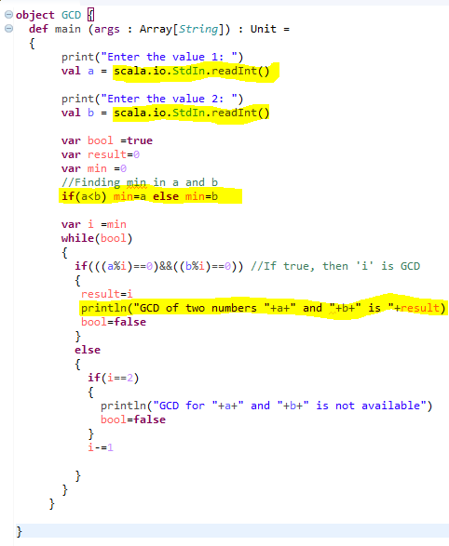

**SAMPLE OUTPUT 1:-**

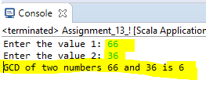

**SAMPLE OUTPUT 2:-**

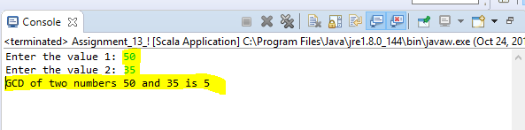

**Program Code:-**

**object** GCD {

**def** main (args : Array[*String*]) : Unit =

{

print("Enter the value 1: ")

**val** a = scala.io.StdIn.readInt()

print("Enter the value 2: ")

**val** b = scala.io.StdIn.readInt()

**var** bool =**true**

**var** result=0

**var** min =0

//Finding min in a and b

**if**(a<b) min=a **else** min=b

**var** i =min

**while**(bool)

{

**if**(((a%i)==0)&&((b%i)==0)) //If true, then 'i' is GCD

{

result=i

println("GCD of two numbers "+a+" and "+b+" is "+result)

bool=**false**

}

**else**

{

**if**(i==2)

{

println("GCD for "+a+" and "+b+" is not available")

bool=**false**

}

i-=1

}

}

}

}